

Computer Engineering Department
Course name: Web Technologies
Course code: 2CP08
Faculty: Prof Kirtikumar Sharma

ID: 23CP029
Name: Viral Vipulkumar Bhoi
Topic: Report of LAB - 5

LAB 3: Cascading Style Sheets (CSS) @import CSS, Apply style to ordered List, Descendant Selectors, child selectors, first-line, first-letter, :before, :after pseudo element, positioning, BOX Model

TABLE OF CONTENT:

5.1 Brief introduction of used CSS . . . . . . . . . . . . . . . . . . . . . . . . . . . . . . . . . . . . . . . . . . . . . . . 3
5.2 Exercise 1 . . . . . . . . . . . . . . . . . . . . . . . . . . . . . . . . . . . . . . . . . . . . . . . . . . . . . . . . . . . . . . . 4
5.3 Exercise 2 . . . . . . . . . . . . . . . . . . . . . . . . . . . . . . . . . . . . . . . . . . . . . . . . . . . . . . . . . . . . . . . 7
5.4 Exercise 3 . . . . . . . . . . . . . . . . . . . . . . . . . . . . . . . . . . . . . . . . . . . . . . . . . . . . . . . . . . . . . . . 10

5.1 Brief introduction of used CSS::

- Positioning:
  - Static (default): Elements appear in the normal document flow.
  - Relative: Positioned relative to its normal position without affecting other elements.
  - Absolute: Removed from the document flow and positioned relative to the nearest positioned ancestor (or <html> if no ancestor is positioned).
  - Fixed: Stays fixed relative to the viewport, unaffected by scrolling.
  - Sticky: Switches between relative and fixed depending on scroll position.
- Z-index:
  - Elements with a higher z-index appear above those with a lower value.
  - Work only with Following positions: relative, absolute, fixed, sticky
  - Can have positive, negative, or zero values
- Descendant Selector:
  - It is used to select all nested elements inside parent.
  - Example: div p{ /*css*/}
  - It selects all p tags inside div.
- Child Selector:
  - Selects only direct child elements of a parent.
  - Example: p > a{/*css*/}
  - It selects only that a who is direct child of p.
- Adjacent Sibling Selector:
  - Selects an element that is immediately next to another element.
  - Example: h1 + p{/*css*/}
  - first p immediately following an h1.
- CSS Box Model:
  - The CSS Box Model describes how elements are structured and spaced in a webpage.
  - Content: The actual text, image, or other content inside the element.
  - Padding: Space inside the element, between the content and the border.
  - Border: A boundary around the element.
  - Margin: Space outside the element, separating it from other elements
- OL:
  - list-style-type: used for changing style of list.
  - text-indent: used in li for giving indentation.

5.2 Exercise 1:

HTML:

<HTML>
<HEAD>
<TITLE> OL STYLING </TITLE>
<link rel="stylesheet" href="style.css">
</HEAD>

<BODY>
<P> Title: Web Technologies </P>
<P>Table of content </P>

<OL>
<LI> HTML </LI>
<LI> CSS </LI>

<OL>
<LI> INTRODUCTION </LI>
<LI> ADDING STYLESHEET </LI>

<OL>
<LI> EXTERNAL </LI>

<OL>
<LI> EXTERNAL STYLE SHEETS ARE USEFUL </LI>
</OL>
</OL>
<LI> BROWSER INCOMPATIBILITY </LI>
</OL>
<LI> XML </LI>
</OL>
</BODY>
</HTML>

CSS:

body{
text-transform: lowercase;
}
ol{
list-style-type : none;
}

body> ol{
counter-reset : cnt1;
}
body> ol> ol{
counter-reset : cnt2;
}
body> ol> ol> ol {
counter-reset : cnt3;
}
body> ol> ol> ol> ol{
counter-reset : cnt4;
}

body> ol>li::before{
counter-increment : cnt1;
content: "Chapter " counter(cnt1)".";
}

body> ol> ol>li::before{
counter-increment : cnt2;
content: counter(cnt1)"."counter(cnt2);
}
body> ol> ol> ol>li::before {
counter-increment : cnt3;
content: counter(cnt1)"."counter(cnt2)"."counter(cnt3);
}
body> ol> ol> ol> ol>li::before {
counter-increment : cnt4;
content: counter(cnt1)"."counter(cnt2)"."counter(cnt3)"."counter(cnt4);
}

OUTPUT:

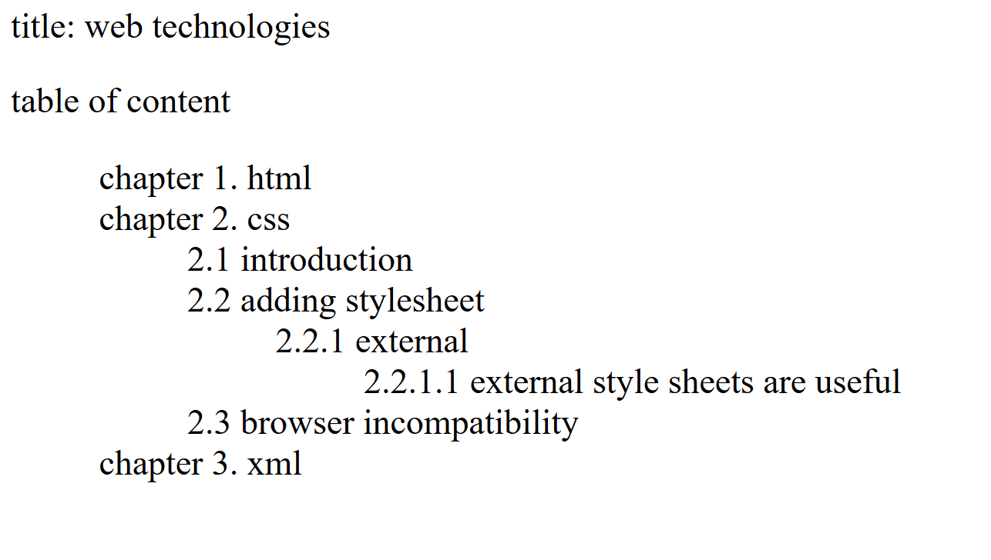

5.3 Exercise 2:

HTML:

<html>
<head>
<title> layout </title>
<link rel="stylesheet" href="style2.css">
</head>
<body>
<div id="header"> <h1>Header</h1> </div>
<div id="left"><h1>Left</h1> </div>
<div id="main"><h1>Main</h1> </div>
</body>
</html>

CSS:

*{
padding:0;
margin:0;
}
#header{
background : #f8f8f8;
width: 100vw;
height:20vh;
position: sticky;
top: 0;
}

#left{
height: 80vh;
width: 20vw;
display: inline-block;
background: #c5c5c5;
position: absolute;
left: 0;
bottom: 0;
}
#main{
height: 80vh;
width: 80vw;
display: inline-block;
background: #878787;
position: absolute;
right: 0;
bottom: 0;
z-index: 3;
}
h1{
display: block;
width: 10%;
margin: auto;
}

OUTPUT:

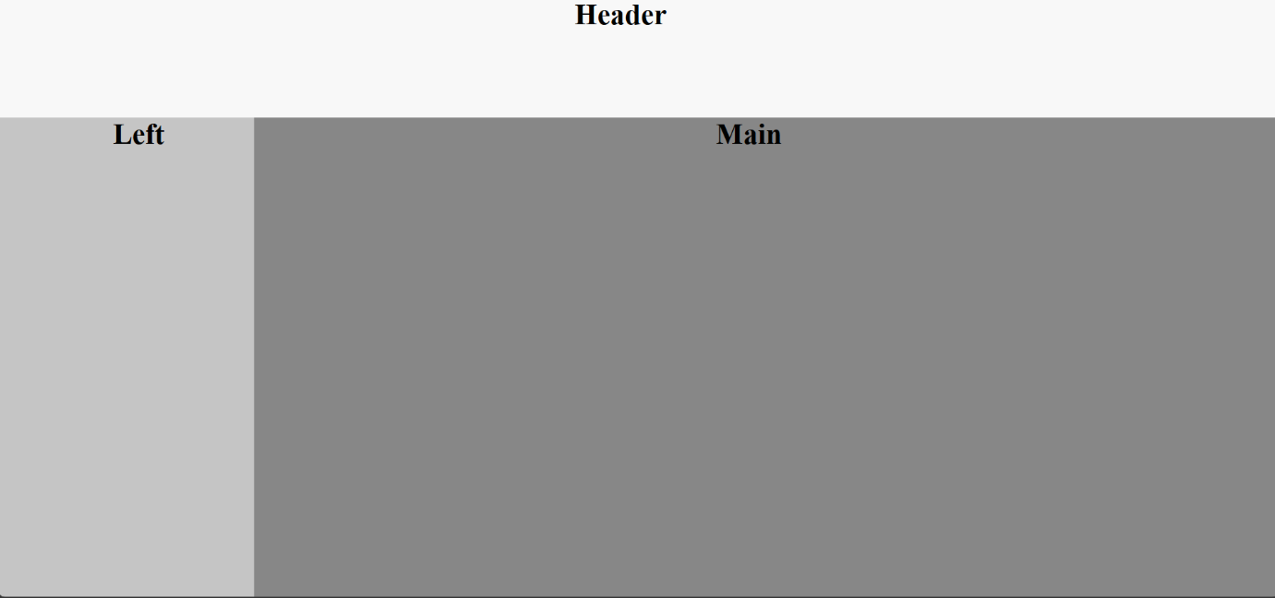

5.4 Exercise 3:

HTML:

<html>
<head>
<title> Box model </title>
<link rel="stylesheet" href="style3.css">
</head>
<body>
<div>
<h1> Local Finder </h1>
<ul>
<li> help user to check their needed product nearby </li>
<li> gives experience of comparing prices at comfort of home </li>
<li> physical shopping expirence </li>
</ul>
</div>
</body>
</html>

CSS:

div{
border: 3px solid #222;
border-radius: 7px;
padding : 20px;
width: 500px;
margin: auto;
margin-top : 20vh;
font-family: Arial;
}
div:hover{
background : linear-gradient(#023992,#F5FFFA);
}
h1:hover{
text-decoration : underline;
font-family: 'Times New Roman';
}
li:hover{
color : #010101;
font-size: 110%;
background : #CCDDDD;
}

OUTPUT:

